Deep learning is a subfield of machine learning, which is, in turn, a subfield of artificial intelligence (AI). For a graphical depiction of this relationship, please refer to Figure 2.1.
The central goal of AI is to provide a set of algorithms and techniques that can be used to solve problems that humans perform intuitively and near automatically, but are otherwise very challenging for computers. A great example of such a class of AI problems is interpreting and understanding the contents of an image – this task is something that a human can do with little-to-no effort, but it has proven to be extremely difficult for machines to accomplish.
While AI embodies a large, diverse set of work related to automatic machine reasoning (inference, planning, heuristics, etc.), the machine learning subfield tends to be specifically interested in pattern recognition and learning from data.
Artificial Neural Networks (ANNs) are a class of machine learning algorithms that learn from data and specialize in pattern recognition, inspired by the structure and function of the brain. As we’ll find out, deep learning belongs to the family of ANN algorithms, and in most cases, the two terms can be used interchangeably. In fact, you may be surprised to learn that the deep learning field has been around for over 60 years, going by different names and incarnations based on research trends, available hardware and datasets, and popular options of prominent researchers at the time.
we’ll review a brief history of deep learning, discuss what makes a neural network “deep”, and discover the concept of “hierarchical learning” and how it has made deep learning one of the major success stories in modern day machine learning and computer vision.

Figure 2.1: A Venn diagram describing deep learning as a subfield of machine learning which a subfield of artificial intelligence is in turn.

Convolutional Neural Networks
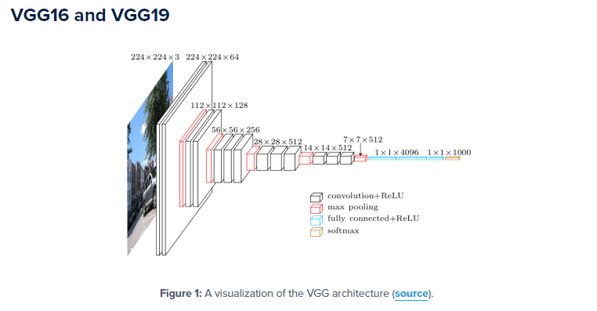
Each layer in a CNN applies a different set of filters, typically hundreds or thousands of them, and combines the results, feeding the output into the next layer in the network. During training, a
CNN automatically learns the values for these filters.
In the context of image classification, our CNN may learn to:
- Detect edges from raw pixel data in the first layer.
- Use these edges to detect shapes (i.e., “blobs”) in the second layer.
- Use these shapes to detect higher-level features such as facial structures, parts of a car, etc.in the highest layers of the network.
The last layer in a CNN uses these higher-level features to make predictions regarding the
Contents of the image.
In terms of deep learning, an (image) convolution is an element-wise multiplication of two matrices followed by a sum.
1. Take two matrices (which both have the same dimensions).
2. Multiply them, element-by-element (i.e., not the dot product, just a simple multiplication).
3. Sum the elements together.
Kernels
Again, let’s think of an image as a big matrix and a kernel as a tiny matrix (at least in respect to the
original “big matrix” image), depicted in Figure 11.1. As the figure demonstrates, we are sliding
the kernel (red region) from left-to-right and top-to-bottom along the original image. At each
(x;y)-coordinate of the original image, we stop and examine the neighborhood of pixels located at
the center of the image kernel. We then take this neighborhood of pixels, convolve them with the
kernel, and obtain a single output value. The output value is stored in the output image at the same
(x;y)-coordinates as the center of the kernel.
If this sounds confusing, no worries, we’ll be reviewing an example in the next section. But
before we dive into an example, let’s take a look at what a kernel looks like (Figure 11.3):
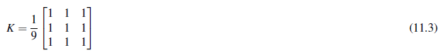

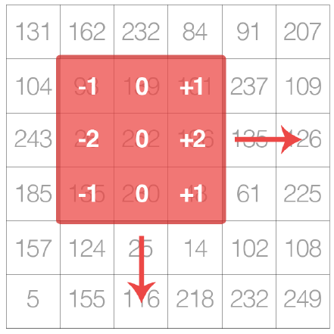
Figure 11.1: A kernel can be visualized as a small matrix that slides across, from left-to-right and
top-to-bottom, of a larger image. At each pixel in the input image, the neighborhood of the image
is convolved with the kernel and the output stored.

We use an odd kernel size to ensure there is a valid integer (x;y)-coordinate at the center of
the image (Figure 11.2). On the left, we have a 3_3 matrix. The center of the matrix is located at
x = 1;y = 1 where the top-left corner of the matrix is used as the origin and our coordinates are
zero-indexed. But on the right, we have a 2_2 matrix. The center of this matrix would be located
at x = 0:5;y = 0:5.
But as we know, without applying interpolation, there is no such thing as pixel location
(0:5;0:5) – our pixel coordinates must be integers! This reasoning is exactly why we use odd kernel
sizes: to always ensure there is a valid (x;y)-coordinate at the center of the kernel.

Example of Convolution
Now that we have discussed the basics of kernels, let’s discuss the actual convolution operation and
see an example of it actually being applied to help us solidify our knowledge. In image processing,
a convolution requires three components:
1. An input image.
2. A kernel matrix that we are going to apply to the input image.
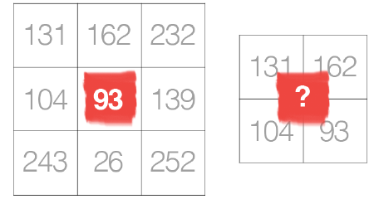
Figure 11.2: Left: The center pixel of a 3_3 kernel is located at coordinate (1;1) (highlighted in
red). Right: What is the center coordinate of a kernel of size 2_2?
3. An output image to store the output of the image convolved with the kernel.
Convolution (i.e., cross-correlation) is actually very easy. All we need to do is:
1. Select an (x;y)-coordinate from the original image.
2. Place the center of the kernel at this (x;y)-coordinate.
3. Take the element-wise multiplication of the input image region and the kernel, then sum
up the values of these multiplication operations into a single value. The sum of these
multiplications is called the kernel output.
4. Use the same (x;y)-coordinates from Step #1, but this time, store the kernel output at the
same (x;y)-location as the output image.
Below you can find an example of convolving (denoted mathematically as the ? operator) a
3_3 region of an image with a 3_3 kernel used for blurring:
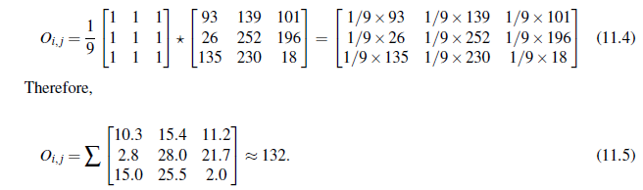
After applying this convolution, we would set the pixel located at the coordinate (i; j) of the
output image O to Oi; j = 132.
That’s all there is to it! Convolution is simply the sum of element-wise matrix multiplication
between the kernel and neighborhood that the kernel covers of the input image.
Layer Types

There are many types of layers used to build Convolutional Neural Networks, but the ones you are most likely to encounter include:
- Convolutional (CONV)
- Activation (ACT or RELU, where we use the same of the actual activation function)
- Pooling (POOL)
- Fully-connected (FC)
- Batch normalization (BN)
- Dropout (DO)

Stacking a series of these layers in a specific manner yields a CNN. We often use simple text diagrams to describe a CNN: INPUT => CONV => RELU => FC => SOFTMAX
Here we define a simple CNN that accepts an input, applies a convolution layer, then an activation layer, then a fully-connected layer, and, finally, a softmax classifier to obtain the output classification probabilities. The SOFTMAX activation layer is often omitted from the network diagram as it is assumed it directly follows the final FC.
Of these layer types, CONV and FC, (and to a lesser extent, BN) are the only layers that contain parameters that are learned during the training process. Activation and dropout layers are not considered true “layers" themselves, but are often included in network diagrams to make the architecture explicitly clear. Pooling layers (POOL), of equal importance as CONV and FC, are also included in network diagrams as they have a substantial impact on the spatial dimensions of an image as it moves through a CNN.
CONV, POOL, RELU, and FC are the most important when defining your actual network architecture. That’s not to say that the other layers are not critical, but take a backseat to this critical set of four as they define the actual architecture itself.

NOTE:Activation functions themselves are practically assumed to be part of the architecture, When defining CNN architectures we often omit the activation layers from a table/diagram to save space; however, the activation layers are implicitly assumed to be part of the architecture.
In the remainder of this section, we’ll review each of these layer types in detail and discuss the parameters associated with each layer (and how to set them). Later in this chapter I’ll discuss in more detail how to stack these layers properly to build your own CNN architectures.

Convolutional Layers
The CONV layer is the core building block of a Convolutional Neural Network. The CONV layer parameters consist of a set of K learnable filters (i.e., “kernels”), where each filter has a width and a height, and are nearly always square. These filters are small (in terms of their spatial dimensions) but extend throughout the full depth of the volume.
For inputs to the CNN, the depth is the number of channels in the image (i.e., a depth of three when working with RGB images, one for each channel). For volumes deeper in the network, the depth will be the number of filters applied in the previous layer. To make this concept more clear, let’s consider the forward-pass of a CNN, where we convolve each of the K filters across the width and height of the input volume, just like we did in Section
11.1.5 above. More simply, we can think of each of our K kernels sliding across the input region,
computing an element-wise multiplication, summing, and then storing the output value in a 2-
dimensional activation map, such as in Figure 11.6.

Figure 11.6: Left: At each convolutional layer in a CNN, there are K kernels applied to the input
volume. Middle: Each of the K kernels is convolved with the input volume. Right: Each kernel
produces an 2D output, called an activation map.

After applying all K filters to the input volume, we now have K, 2-dimensional activation maps.
We then stack our K activation maps along the depth dimension of our array to form the final output
volume (Figure 11.7).
Figure 11.7: After obtaining the K activation maps, they are stacked together to form the input
volume to the next layer in the network.

Every entry in the output volume is thus an output of a neuron that “looks” at only a small region of the input. In this manner, the network “learns” filters that activate when they see a specific type of feature at a given spatial location in the input volume. In lower layers of the network, filters may activate when they see edge-like or corner-like regions.
Then, in the deeper layers of the network, filters may activate in the presence of high-level features, such as parts of the face, the paw of a dog, the hood of a car, etc. This activation concept goes back to our neural network analogy in Chapter 10 – these neurons are becoming “excited” and “activating” when they see a particular pattern in an input image.

The concept of convolving a small filter with a large(r) input volume has special meaning in
Convolutional Neural Networks – specifically, the local connectivity and the receptive field of
a neuron. When working with images, it’s often impractical to connect neurons in the current volume to all neurons in the previous volume – there are simply too many connections and too many weights, making it impossible to train deep networks on images with large spatial dimensions.
Instead, when utilizing CNNs, we choose to connect each neuron to only a local region of the input volume – we call the size of this local region the receptive field (or simply, the variable F) of the neuron.
To make this point clear, let’s return to our CIFAR-10 dataset where the input volume as an input size of 32_32_3. Each image thus has a width of 32 pixels, a height of 32 pixels, and a depth of 3 (one for each RGB channel). If our receptive field is of size 3_3, then each neuron in the CONV layer will connect to a 3_3 local region of the image for a total of 3_3_3 = 27 weights (remember, the depth of the filters is three because they extend through the full depth of the input image, in this case, three channels).
Now, let’s assume that the spatial dimensions of our input volume have been reduced to a smaller size, but our depth is now larger, due to utilizing more filters deeper in the network, such that the volume size is now 16_16_94. Again, if we assume a receptive field of size 3_3, then every neuron in the CONV layer will have a total of 3_3_94=846 connections to the input volume.
Simply put, the receptive field F is the size of the filter, yielding an F _F kernel that is convolved with the input volume.
At this point we have explained the connectivity of neurons in the input volume, but not the arrangement or size of the output volume. There are three parameters that control the size of an output volume: the depth, stride, and zero-padding size, each of which we’ll review below.
Depth
The depth of an output volume controls the number of neurons (i.e., filters) in the CONV layer that connect to a local region of the input volume. Each filter produces an activation map that “activate” in the presence of oriented edges or blobs or color.
For a given CONV layer, the depth of the activation map will be K, or simply the number of
filters we are learning in the current layer. The set of filters that are “looking at” the same (x;y)
location of the input is called the depth column.
Zero-padding
As we know from Section 11.1.5, we need to “pad” the borders of an image to retain the original
image size when applying a convolution – the same is true for filters inside of a CNN. Using
zero-padding, we can “pad” our input along the borders such that our output volume size matches
our input volume size. The amount of padding we apply is controlled by the parameter P.
This technique is especially critical when we start looking at deep CNN architectures that apply
multiple CONV filters on top of each other. To visualize zero-padding, again refer to Table 11.1
where we applied a 3_3 Laplacian kernel to a 5_5 input image with a stride of S = 1.
We can see in Table 11.3 (left) how the output volume is smaller (3_3) than the input volume
(5_5) due to the nature of the convolution operation. If we instead set P = 1, we can pad our input
volume with zeros (middle) to create a 7_7 volume and then apply the convolution operation,
leading to an output volume size that matches the original input volume size of 5_5 (right).
Without zero padding, the spatial dimensions of the input volume would decrease too quickly,
and we wouldn’t be able to train deep networks (as the input volumes would be too tiny to learn
any useful patterns from).
Putting all these parameters together, we can compute the size of an output volume as a function
of the input volume size (W, assuming the input images are square, which they nearly always are),
the receptive field size F, the stride S, and the amount of zero-padding P. To construct a valid CONV
Activation Layers
After each CONV layer in a CNN, we apply a nonlinear activation function, such as ReLU, ELU, or
any of the other Leaky ReLU variants mentioned in Chapter 10. We typically denote activation
layers as RELU in network diagrams as since ReLU activations are most commonly used, we may
also simply state ACT – in either case, we are making it clear that an activation function is being
applied inside the network architecture.
Activation layers are not technically “layers” (due to the fact that no parameters/weights are
learned inside an activation layer) and are sometimes omitted from network architecture diagrams
as it’s assumed that an activation immediately follows a convolution.
In this case, authors of publications will mention which activation function they are using
after each CONV layer somewhere in their paper. As an example, consider the following network
architecture: INPUT => CONV => RELU => FC.
To make this diagram more concise, we could simply remove the RELU component since it’s
assumed that an activation always follows a convolution: INPUT => CONV => FC. I personally do
not like this and choose to explicitly include the activation layer in a network diagram to make it
clear when and what activation function I am applying in the network.
An activation layer accepts an input volume of sizeWinput _Hinput _Dinput and then applies the
given activation function (Figure 11.9). Since the activation function is applied in an element-wise
manner, the output of an activation layer is always the same as the input dimension,Winput =Wout put ,
Hinput = Hout put , Dinput = Dout put .

Pooling Layers

There are two methods to reduce the size of an input volume – CONV layers with a stride > 1 (which
we’ve already seen) and POOL layers. It is common to insert POOL layers in-between consecutive
Figure 11.9: An example of an input volume going through a ReLU activation, max(0;x). Activations
are done in-place so there is no need to create a separate output volume although it is easy to
visualize the flow of the network in this manner.

CONV layers in a CNN architectures:
INPUT => CONV => RELU => POOL => CONV => RELU => POOL => FC

The primary function of the POOL layer is to progressively reduce the spatial size (i.e., width
and height) of the input volume. Doing this allows us to reduce the amount of parameters and
computation in the network – pooling also helps us control overfitting.
POOL layers operate on each of the depth slices of an input independently using either the
max or average function. Max pooling is typically done in the middle of the CNN architecture
to reduce spatial size, whereas average pooling is normally used as the final layer of the network

(e.x., GoogLeNet, SqueezeNet, ResNet) where we wish to avoid using FC layers entirely. The most
common type of POOL layer is max pooling, although this trend is changing with the introduction
of more exotic micro-architectures.
Typically we’ll use a pool size of 2_2, although deeper CNNs that use larger input images
(> 200 pixels) may use a 3_3 pool size early in the network architecture. We also commonly set
the stride to either S = 1 or S = 2. Figure 11.10 (heavily inspired by Karpathy et al. [121]) follows
an example of applying max pooling with 2_2 pool size and a stride of S = 1. Notice for every
2_2 block, we keep only the largest value, take a single step (like a sliding window), and apply
the operation again – thus producing an output volume size of 3_3.
We can further decrease the size of our output volume by increasing the stride – here we apply
S = 2 to the same input (Figure 11.10, bottom). For every 2_2 block in the input, we keep only
the largest value, then take a step of two pixels, and apply the operation again. This pooling allows
us to reduce the width and height by a factor of two, effectively discarding 75% of activations from
the previous layer.
In summary, POOL layers Accept an input volume of size Winput _Hinput _Dinput . They then
require two parameters:
- The receptive field size F (also called the “pool size”).
- The stride S.
Applying the POOL operation yields an output volume of sizeWout put _Hout put _Dout put , where:
- Wout put = ((Winput 􀀀F)=S)+1
- Hout put = ((Hinput 􀀀F)=S)+1
- Dout put = Dinput
In practice, we tend to see two types of max pooling variations:
_ Type #1: F = 3;S = 2 which is called overlapping pooling and normally applied to images/
input volumes with large spatial dimensions.

Figure 11.10: Left: Our input 4_4 volume. Right: Applying 2_2 max pooling with a stride of
S = 1. Bottom: Applying 2_2 max pooling with S = 2 – this dramatically reduces the spatial
dimensions of our input.

Fully-connected Layers
Neurons in FC layers are fully-connected to all activations in the previous layer, as is the standard for feedforward neural networks that we’ve been discussing in Chapter 10. FC layers are always placed at the end of the network (i.e., we don’t apply a CONV layer, then an FC layer, followed by another CONV) layer. It’s common to use one or two FC layers prior to applying the softmax classifier, as the following (simplified) architecture demonstrates:

INPUT => CONV => RELU => POOL => CONV => RELU => POOL => FC => FC
Here we apply two fully-connected layers before our (implied) softmax classifier which will compute our final output probabilities for each class.

Batch Normalization
First introduced by Ioffe and Szgedy in their 2015 paper, Batch Normalization: Accelerating Deep Network Training by Reducing Internal Covariate Shift [123], batch normalization layers (or BN for short), as the name suggests, are used to normalize the activations of a given input volume before passing it into the next layer in the network. If we consider x to be our mini-batch of activations, then we can compute the normalized ˆ x via the following equation

We set e equal to a small positive value such as 1e-7 to avoid taking the square root of zero.
Applying this equation implies that the activations leaving a batch normalization layer will have approximately zero mean and unit variance (i.e., zero-centered).
At testing time, we replace the mini-batch mb and sb with running averages of mb and sb computed during the training process. This ensures that we can pass images through our network and still obtain accurate predictions without being biased by the mb and sb from the final mini-batch passed through the network at training time. Batch normalization has been shown to be extremely effective at reducing the number of epochs it takes to train a neural network. Batch normalization also has the added benefit of helping “stabilize” training, allowing for a larger variety of learning rates and regularization strengths. Using batch normalization doesn’t alleviate the need to tune these parameters of course, but it will make your life easier by making learning rate and regularization less volatile and more straightforward to tune. You’ll also tend to notice lower final loss and a more stable loss curve when using batch normalization in your networks.
The biggest drawback of batch normalization is that it can actually slow down the wall time it takes to train your network (even though you’ll need fewer epochs to obtain reasonable accuracy) by 2-3x due to the computation of per-batch statistics and normalization.
That said, I recommend using batch normalization in nearly every situation as it does make a significant difference. As we’ll see later in this book, applying batch normalization to our network architectures can help us prevent overfitting and allows us to obtain significantly higher classification accuracy in fewer epochs compared to the same network architecture without batch normalization.

Dropout
The last layer type we are going to discuss is dropout. Dropout is actually a form of regularization that aims to help prevent overfitting by increasing testing accuracy, perhaps at the expense of training accuracy. For each mini-batch in our training set, dropout layers, with probability p, randomly disconnect inputs from the preceding layer to the next layer in the network architecture.
Figure 11.11 visualizes this concept where we randomly disconnect with probability p=0:5 the connections between two FC layers for a given mini-batch. Again, notice how half of the connections are severed for this mini-batch. After the forward and backward pass are computed for the minibatch, we re-connect the dropped connections, and then sample another set of connections to drop.
The reason we apply dropout is to reduce overfitting by explicitly altering the network architecture at training time. Randomly dropping connections ensures that no single node in the network is responsible for “activating” when presented with a given pattern. Instead, dropout ensures there are multiple, redundant nodes that will activate when presented with similar inputs – this in turn helps our model to generalize.
It is most common to place dropout layers with p = 0:5 in-between FC layers of an architecture
where the final FC layer is assumed to be our softmax classifier:
Serializing a Model to Disk
Using the Keras library, model serialization is as simple as calling model.save on a trained model
and then loading it via the load_model function.

The LeNet Architecture
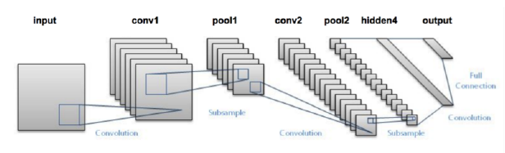
Figure 14.1: The LeNet architecture consists of two series of CONV => TANH => POOL layer sets
followed by a fully-connected layer and softmax output.

